# Table of Contents

Table of Contant 1

Table of figures 1

Table of tables 1

A. What is the problem your client wants you to address? 2

B. Who is affected by this problem? 4

❖ Problem: Waste Management problem in coffee industry (using the 5 why’s). 5

C. What are the causes and effects of this problem? 6

❖ Causes of poor waste management: 6

❖ Effects of poor waste management: 7

D. Additional information addressed to this Problem. 7

References: 9

# Table of figures

Figure 1 Plastic Trash in the Pasig River Philippines (importers of plastic waste) 4

Figure 2 Problem Analysis Tree for waste management 6

# Table of tables

Table 1 Health problems (Alemayehu Haddis, 2008) [13] 3

**ZUS Stainability**

The urgency to maintain daily wastage in the Food and beverage industry have been growing everyday [1]. Although there have been many attempts to reduce the wastage in the beverage industry, the set standard of the waste regulatory bodies seems to be impossible to meet. The drinks in the beverage industry are usually served in bottles or cans made from glass or plastics. Glasses takes longer to decompose compared to plastics. Glasses takes almost 1 million years whereas plastic takes 450+ years. It may seem that glasses take longer to degrade but glasses can be reused but plastics are suggested not to reuse as they emit toxic chemicals that is harmful both to human bodies and to the environment [2].

# What is the problem your client wants you to address?

The problem that will be discussed in this report is Waste Management in Zus coffee. Zus coffee was first opened in 2019 and since then it has been growing to 100s of branches in Malaysia [3]. Its main business is to serve daily specialty coffee to its customers along with other desserts and snacks. So, how well does Zus coffee manage its waste?  
First let’s investigate the problem with waste management in the coffee industry. It is well known that coffee industry impacts the environment. The steps included in the process of buying coffee, roasting or shipping coffees uses energy and therefore has its own carbon footprint [4]. Moreover, it is just not the process of buying and selling, it is also the leftover coffee grounds that are discarded which causes waste. The coffee grounds should be disposed or reused in a way so that the landfills are not occupied. Coffee pulp/hulks contains caffeine which causes coffees that are to be disposed harmful to the environment. Majority of the coffee pulps are thrown into the nearby lake or river which pollutes the water [5]. The civilization nearby who uses the stream/lake water every day in their household gets sick. The health problems reported by the people living nearby the polluted lake where the coffee pulps or husks has been dumped is listed in Table 1.

Table 1 Health problems (Alemayehu Haddis, 2008) [13]

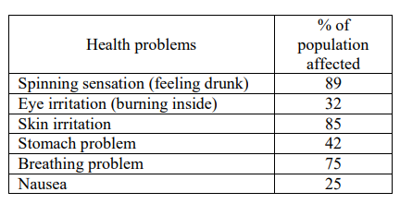

However, coffee grounds are not always a bad problem. Coffee grounds are organic so if they are thrown into the garbage which is later disposed to the landfills, the landfills become rich in nutrients and can be used for other purposes. Although the question remains how do the coffee shops in Malaysia manage their waste management? The coffee grounds get mouldy easily and since high pressure water is used to make coffees in the high-end coffee shops the remain of the coffee grounds cannot be reused and Malaysia does not have the latest technology to make these coffee grounds useful [6].

The coffee grounds are not the only issue that the environment is facing from the well-known coffee industry. It is also the millions and millions of plastics uses which happens every day all over the world. The question that arises is how do the coffee places dispose the used plastics or glass? Coffees are usually served in cups made from plastics or cartoons. The cold coffees are served in plastic containers specially. What happens to those plastics after they are thrown to the garbage bin? Are they recycled? Or are they just dumped to the landfill and to the seas? The F&B industry is the primary source of plastic waste generation and almost 141 mega tonnes of plastic waste has been generated in 2015 [7]. According to the report produced by Ministry of Housing and Local Government Malaysia, plastic waste is dumped into the landfills as that is the only existing method available in Malaysia. Plastics are not recycled in Malaysia because they fall under the category of 4 to 7 which are cheap and is rarely recycled or not recyclable. The plastic of grade 1 to 2 are the most recycled but the plastic that is produced after recycling are cheap quality so they cannot be reused. Due to this reason, they eventually end up in landfills most of the time [7].

# Who is affected by this problem?

Every problem has an adverse effect. The waste management problem is affecting the people of Malaysia. Coffee industry is a huge business worldwide and therefore produces a lot of plastic. Malaysia already has its own plastic waste to deal with from many different industries but mainly food & beverage [7]. It has been reported that wastes from Europe is being shipped to Malaysia to be dumped here [8]. There are few other countries who are accepting these wastes. These wastes mainly contain of plastics which are then dumped to the landfills and eventually it goes to the sea. First the dumped waste contains toxic chemicals which causes the landfills and the environment to become polluted and secondly when they are dumped to the sea, the sea creatures get affected by it. Malaysia does not have proper waste management as mentioned above [7]. So, when more wastes are being imported from abroad to be dumped here it gets difficult. Directly the people are getting affected by these wastes and indirectly the sea creatures are affected. When the people living nearby these sea bodies use this contaminated water, they have severe health diseases. Moreover, the sea creatures caught from this water which are then being eaten everyday by the people can also cause health issues. ‘It is necessary that we get a grip on plastic usage and production if we want to make an impact on the waste management of plastic’ - said by Jim Puckett, BAN’s founder, and executive director [8].

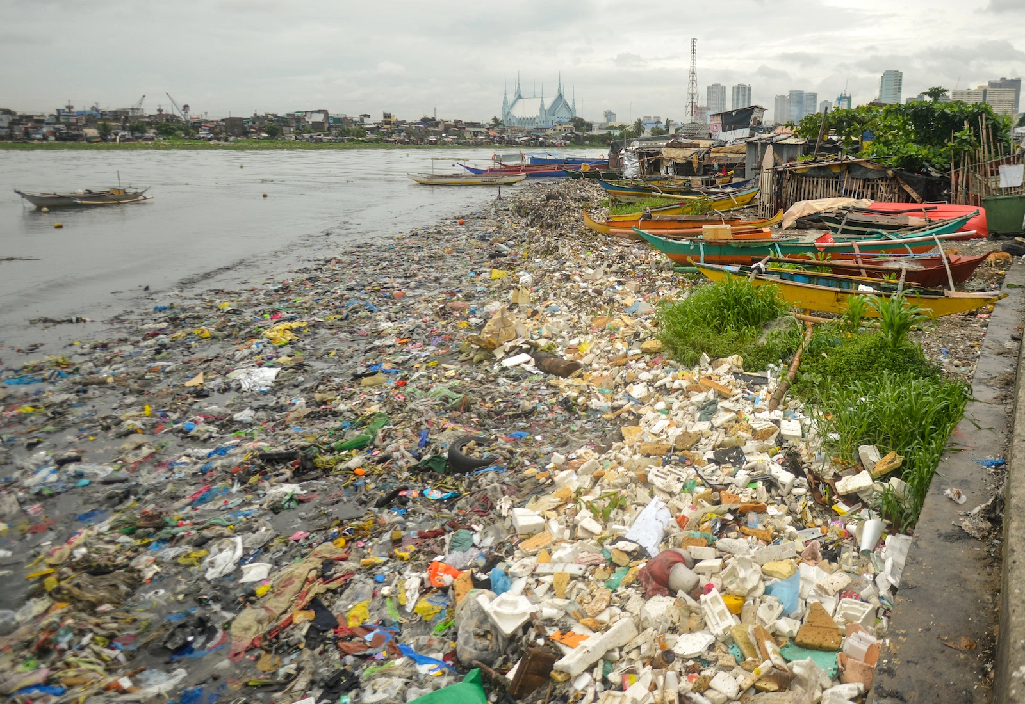

Figure 1 Plastic Trash in the Pasig River Philippines (importers of plastic waste)

Before moving to the next step of knowing the causes and effects of waste management, it should be discussed why there is waste management issue in the coffee industry. The 5 why methods have been used to discuss the issue.

## Problem: Waste Management problem in coffee industry (using the 5 why’s).

1. Why do we have waste management problem in coffee industry? - Because the wastes (plastics) & coffee pulp or grounds are not disposed properly.
2. Why are they not disposed properly? - Because not enough awareness has been created and not enough methods are available for disposal
3. Why are not enough methods available and not enough awareness created? - Because the government does not have enough economic incentives allocated for the methods and the government is not taking the matter of waste disposal seriously [7].
4. Why is government not taking the matter seriously and why is not enough fund allocated? - Because the government is also the people of Malaysia and do not have enough knowledge about the proper way of disposal. Not enough fund is allocated as they give priorities to other things over the waste disposal [9].
5. Why do not the people of Malaysia have enough knowledge about the waste disposal and why give priorities to other things over waste disposal? - The people of Malaysia did not study about the proper wastage disposal and have become accustomed to seeing plastics disposed in the garbage. They are not aware that plastics need to be recycled [7]. Also, the reason why government gives priorities to other matters over the proper disposal method is because the waste disposal method has recently started becoming a big issue. Before it was not a big issue [9].

# What are the causes and effects of this problem?

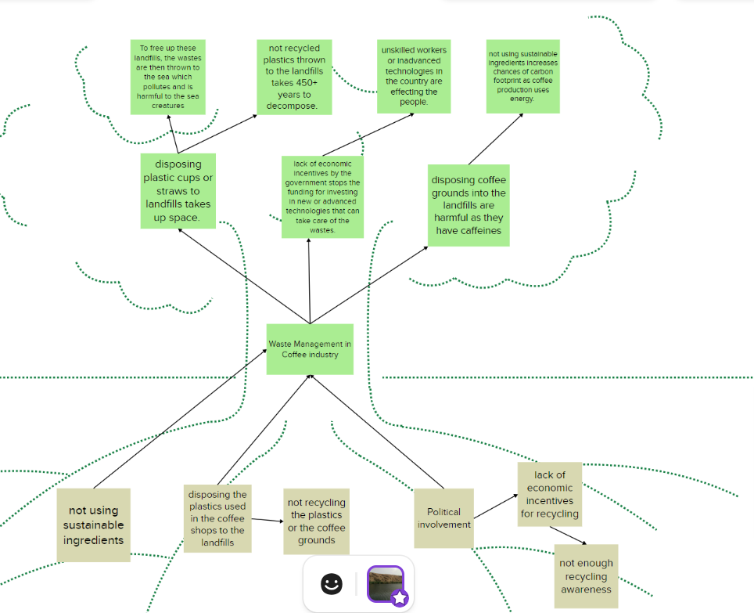

Figure 2 Problem Analysis Tree for waste management

## Causes of poor waste management:

* Not disposing the used plastics utensils properly. Thinking that dumping into the garbage bin is enough [11].
* Not recycling the plastics.
* Disposing coffee grounds into the landfills which contains caffeine and is harmful [10].
* Not using sustainable products or ingredients such as reusable straws or cups. Ingredients such as plant-based milk and more.
* Political involvement. This can be a serious issue as lack of political desire in implementing rules and regulations for the method of waste disposals. As there are no rulings, business owners dispose however they feel convenient [7].
* Lack of economic incentives provided by the government for funding advanced technologies or recycling wastes [7].
* Lack of experts and technologies available in Malaysia who are well educated on the topic of recycle or waste management.
* Lack of awareness amongst the people about waste management.

These are the causes which causes poor waste management in Malaysia’s coffee industry. Due to these causes, there effects both on the nature and on the human beings.

## Effects of poor waste management:

* When the plastic cups or straws are disposed to the landfills, they occupy space.
* Plastics take 450+ years to decompose when thrown into the landfills meaning that for 450+ years that land cannot be used. If the land wants to be used, the wastes need to be moved elsewhere.
* If the lands want to be used, they are then thrown to the sea or nearby river. These causes the sea creatures to be affected and pollute drinking water.
* By not using sustainable products, the chances of carbon footprint increase as coffee production uses energy [12].
* Disposing coffee grounds or pulps into the landfills are harmful as they contain caffeine [4].
* Lack of economic incentives by the government stops the funding for investing in new or advanced technologies that can take care of the wastes.
* Lack of economic incentives by the government stops the funding for investing in new or advanced technologies that can take care of the wastes.
* Unskilled workers who are not aware of proper waste disposal methods and also, unadvanced technologies in the country are affecting the people health and the environment.

# Additional information addressed to this Problem.

All in all, Malaysia and the coffee industry in Malaysia does not have proper waste management system yet. How about Zus coffee? From the research and articles found online it can be seen that Zus coffee tries to maintain waste management system to the best of their capabilities. By keeping their moto in mind ‘Blue is the new green’, they practice sustainability in 4 key areas.

1. Zus Products – Zus coffee partnered with Coffee Roaster and Coffex Coffee and only procures Direct Trade Beans. Direct trade helps farmer to grow with them and have a more sustainable growth and future.

Plant based milk – this milk is environmentally friendly and healthy for the people.

1. Hot/Iced cups are made 100% from food ingredients. Zus Rice Straws are 100% biodegradable and turtle friendly.
2. Zus coffee app allows for 100% paper free receipts. The order can be made online and delivered to customers doorstep or can be picked up.
3. Career opportunities – Zuristas, management training programs [14].

# References:

1. (N.d.-a). https://doi.org/Mohamad Rosman, Mohamad Rahimi &amp; Fadzil, Faizal &amp; Abdullah, Nurulannisa &amp; Mohd Zawawi, Mohd Zafian &amp; Arshad, Izzatil &amp; Md Saleh, Mohamad Sayuti &amp; S Baharuddin, Nurfatihah. (2023). Waste Management Perspective in Malaysia: A Conceptual Framework. 10.5281/zenodo.7890951.
2. (N.d.-b). Coffee Waste Management-An Overview. https://doi.org/Rangarajan, Dr Padmapriya. (2019). Coffee waste management-An overview. International Journal of Current Research. 33. 9-16.
3. 352. (n.d.). Malaysia Waste Management Solutions. International Trade Administration | Trade.gov. https://www.trade.gov/market-intelligence/malaysia-waste-management-solutions#:~:text=According%20to%20the%20National%20Solid,is%20done%20to%20reduce%20waste
4. Corporate communication students discuss the environmental impacts of coffee grounds. UTAR News, Newsletters, In the Press, Awards and Webinars. (n.d.). https://news.utar.edu.my/news/2020/Sept/07/01/01.html
5. Cynthia Ignatius, By, &amp; Ignatius, C. (2023, March 14). Zus coffee to expand with a target of 330 new outlets by end of 2023. BusinessToday. https://www.businesstoday.com.my/2023/03/14/zus-coffee-to-expand-with-a-target-of-380-new-outlets-by-end-of-2023/#:~:text=Now%20in%20its%204th%20year,and%20airports%20across%20the%20country
6. Fernandes, A. S., Mello, F. V. C., Thode Filho, S., Carpes, R. M., Honório, J. G., Marques, M. R. C., Felzenszwalb, I., &amp; Ferraz, E. R. A. (2017). Impacts of discarded coffee waste on human and environmental health. Ecotoxicology and Environmental Safety, 141, 30–36. https://doi.org/10.1016/j.ecoenv.2017.03.011
7. Haddis, A., &amp; Devi, R. (2008). Effect of effluent generated from coffee processing plant on the water bodies and human health in its vicinity. Journal of Hazardous Materials, 152(1), 259–262. https://doi.org/10.1016/j.jhazmat.2007.06.094
8. Kanniah, J. C. (2022, December 12). What happens to coffee grounds after they’re used? Perfect Daily Grind. https://perfectdailygrind.com/2020/09/what-happens-to-coffee-grounds-after-theyre-used/#:~:text=In%20landfills%2C%20this%20creates%20an,and%20contribute%20to%20climate%20change
9. KELLOGG, K. (2019, September 13). Glass or plastic: Which is Better For The Environment? https://www.goingzerowaste.com/. https://www.goingzerowaste.com/blog/which-is-better-for-the-environment-glass-or-plastic/#:~:text=Plastic%20takes%20450%2B%20years%20to,the%20environment%20as%20time%20passes
10. Lee, C. J., Chang, L., &amp; Tan, J. (2022). Environmental Sustainability Framework for Plastic Waste Management—a case study of bubble tea industry in Malaysia. Process Integration and Optimization for Sustainability, 6(2), 513–526. https://doi.org/10.1007/s41660-022-00230-w
11. Michalkwasniewski.com. (2021, October 20). What is the carbon footprint of a cup of coffee?. MTPak Coffee. https://mtpak.coffee/2021/03/coffee-roasters-reduce-carbon-footprint/#:~:text=Other%20contributing%20factors%20to%20the,to%20the%20total%20supply%20chain
12. Samuel, A. U., Oyawale, F., &amp; Fayomi, O. S. I. (2019). Effects of waste management in Beverage Industries: A perspective. Journal of Physics: Conference Series, 1378(2), 022048. https://doi.org/10.1088/1742-6596/1378/2/022048
13. Social Impact - Zus Coffee: Malaysia #1 tech-driven coffee chain. ZUS Coffee | Malaysia #1 Tech-Driven Coffee Chain. (2022, June 8). https://zuscoffee.com/social-impact/
14. Winters, J. (2022, April 21). Rich countries are illegally exporting plastic trash to poor countries, data suggests - InvestigateWest. InvestigateWest - Investigative journalism for the Pacific Northwest. https://www.invw.org/2022/04/18/rich-countries-are-illegally-exporting-plastic-trash-to-poor-countries-data-suggests/#:~:text=Throughout%202021%2C%20Indonesia%2C%20Vietnam%2C,in%202020%20to%2041%20million